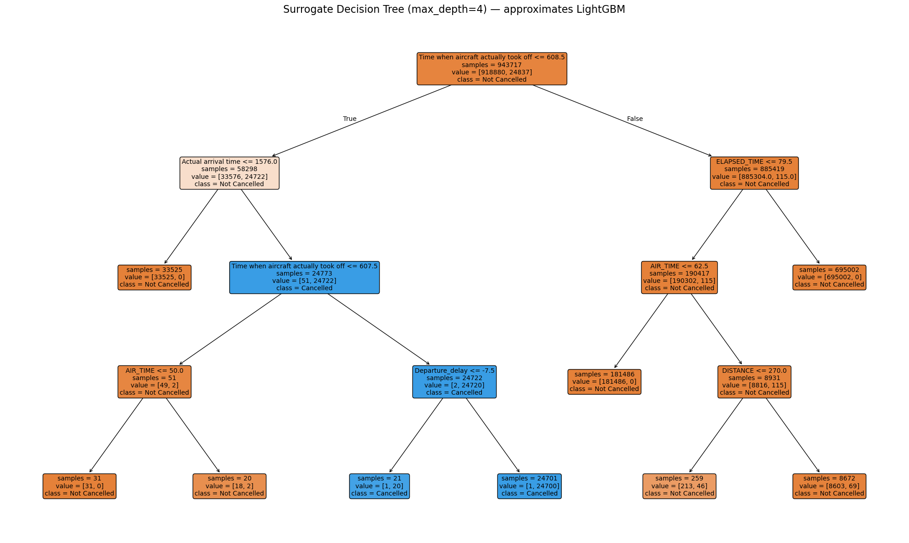
LightGBM Accuracy: 1.0000
📜 Surrogate Decision Tree Rules (human-readable):

|--- Time when aircraft actually took off <= 608.50
| |--- Actual arrival time <= 1576.00
| | |--- class: 0
| |--- Actual arrival time > 1576.00
| | |--- Time when aircraft actually took off <= 607.50
| | | |--- AIR_TIME <= 50.00
| | | | |--- class: 0
| | | |--- AIR_TIME > 50.00
| | | | |--- class: 0
| | |--- Time when aircraft actually took off > 607.50
| | | |--- Departure_delay <= -7.50
| | | | |--- class: 1
| | | |--- Departure_delay > -7.50
| | | | |--- class: 1
|--- Time when aircraft actually took off > 608.50
| |--- ELAPSED_TIME <= 79.50
| | |--- AIR_TIME <= 62.50
| | | |--- class: 0
| | |--- AIR_TIME > 62.50
| | | |--- DISTANCE <= 270.00
| | | | |--- class: 0
| | | |--- DISTANCE > 270.00
| | | | |--- class: 0
| |--- ELAPSED_TIME > 79.50
| | |--- class: 0
